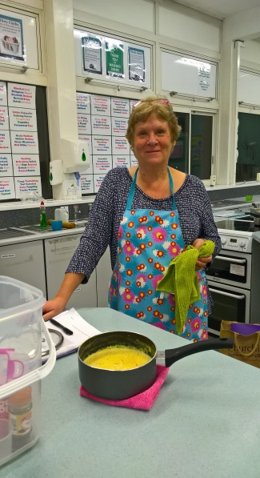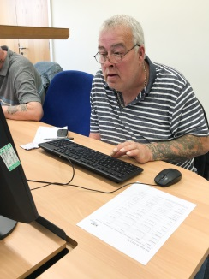

For further details or how to enrol please call our friendly West Adult Learning Team on:

0116 305 3829 (for Coalville) or 0116 305 3901 (for Hinckley)

**The course dates are:**

**Maths at Coalville Library : Tuesday 17th April to 26th June , 10 till 11.30am**

**English at Coalville Library: Friday 20th April to 29th June, 10 till 11.30am**

**Maths at Hinckley Library: Monday 16th April to 2nd July, 10 till 11.30am**

**English at Hinckley Library: Thursday 19th April to 28th June, 1 till 2.30 pm**

FREE

This 10 week course is for those students who have low confidence or have not been in learning for a long time, and are keen to start learning again and get a taste of what learning might be like.

Just choose one of the dates from the choice below.

There will be an opportunity after the course to enrol on Maths and English courses starting in September.

**Maths and English Tasters**

**in Coalville and Hinckley**