

For over 65 years, Sense has offered a wide range of support for families, adults and children with complex disabilities, including deafblindness, which help tackle social isolation and ensures individuals are less lonely and more connected with their communities.  With physical contact now restricted, a series of Sense services are now also available online, to tackle the issue, through the Sense Connect programme. **The below Sense services are all funded by the Government Loneliness Fund and are free of charge, running until the end of December.**

**Please do share with those you think may be interested in any of the strands of the project detailed below.**

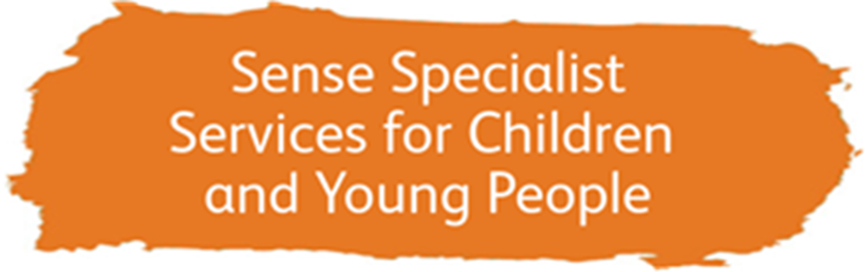

The Sense Children and Families service are offering information and advice, and specialist support and activity sessions, online, for those families that are unable to visit its day centres. Sense Specialist Services for Children and Young People team are running both group sessions bespoke, individualised virtual sessions to increase a young person’s communication skills, access to information and play skills. These sessions will provide the children with meaningful interactions to increase confidence and well-being. We are also providing virtual support groups for parents and carers. These sessions are suitable for children/young people aged 0-25 who have a multi-sensory impairment (deafblindness) or a single sensory impairment and additional needs.

[**Please click here to complete a referral form for Specialist Services for Children and Young People**](https://www.sense.org.uk/get-support/holidays-short-breaks-and-activity-groups/sense-connect-referral/)



The Sense Buddying service, which matches a disabled person with a volunteer, is now also available online, with buddies socialising over phone, videocall or letter.  Our volunteer buddies are carefully matched with people based on their communication style, hobbies and interests, with a focus on having fun together and becoming friends.  Virtual Buddying is suitable for individuals of all ages with communication or sensory needs.

[**Please click here to complete a referral form for Virtual Buddies**](https://www.sense.org.uk/get-support/holidays-short-breaks-and-activity-groups/sense-connect-referral/)

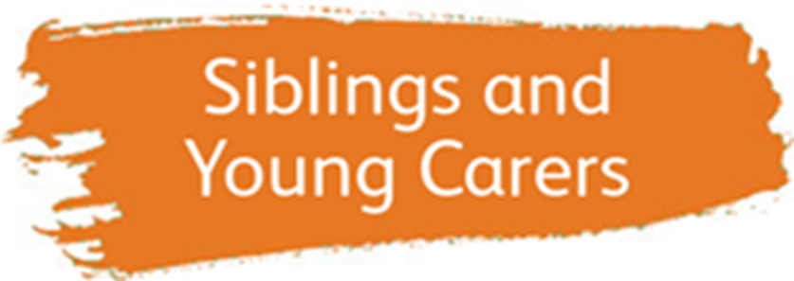

Siblings and Young Carers is a new online project aimed at supporting the wellbeing of young people with a caring role. The project includes both age appropriate group sessions and one to one peer sessions where young people can share their experiences and interests with a fellow sibling or young carer. The Siblings and Young Carers project is suitable for young people aged 5-18 who have a sibling or parent with complex communication needs.

[**Please click here to complete a referral form for the Siblings and Young Carers project**](https://www.sense.org.uk/get-support/holidays-short-breaks-and-activity-groups/sense-connect-referral/)



The Sense Arts and Sports service, which supports people with complex disabilities to access arts and wellbeing activities, as well as sport and physical activity sessions, now also run sessions online, and include the sharing of meaningful resources between volunteers, disabled people and families.  The sessions are interactive, fun and enable people to be creative.

[**Please click here to find out more and to join the mailing list**](https://www.sense.org.uk/get-support/arts-sport-and-wellbeing/)

If you have any questions at all about Sense Connect – please get in touch with us by emailing [sense.connect@sense.org.uk](mailto:sense.connect@sense.org.uk).

Please note, completing a referral form doesn’t guarantee a service can be provided.

Thanks,

**Sian Stamper**  
**Operations Manager (Holidays and Short Breaks)**

**Ofsted Registered Manager**

Mobile:07970369696  
Direct line:     020 7014 9301  
Reception:    0300 330 9250



www.sense.org.uk  
[www.facebook.com/sensecharity](http://www.facebook.com/sensecharity)   
[www.twitter.com/sensecharity](http://www.twitter.com/sensecharity)

[](https://www.sense.org.uk/sense-sign-school/?utm_source=staffemail&utm_medium=emailsignature&utm_campaign=sense_sign_school)

For everyone living with complex disabilities. For everyone who is deafblind. Sense is here to help people communicate and experience the world.

Sense, 101 Pentonville Road, London, N1 9LG  
[www.sense.org.uk](https://www.sense.org.uk)   
Company no 1825301 Charity no 289868  
A company limited by guarantee and registered in England and Wales