

**First Contact Plus is open for business as usual**

We are still offering information & advice, signposting and onward referrals for the residents of Leicestershire.

Some of our referral partners will be offering a reduced service during this time but we will keep our customers informed of what is available.





First Contact Plus Service is leading on making telephone contact with Leicestershire’s shielded residents.

This cohort has been identified as needing to self-isolate for 12 weeks due to being extremely clinically vulnerable. The team is being supported by ASC staff to ensure this time critical task is addressed quickly.

To date over 12,000 calls have been made to this shielded group. Support is arranged to address requests for emergency food parcels, support with on-going shopping, socialisation, picking up medication and unmet social care needs. Staff have worked tirelessly during the normal working day, evenings and weekends to get through the task.

.





**First Contact Plus Performance – Year on Year**

First Contact Plus has shown a year on year growth in the number of referrals received. We had a drop in March this year because of Covid 19 but have remained higher than previous years. Thank you to all our partners for their continued support.



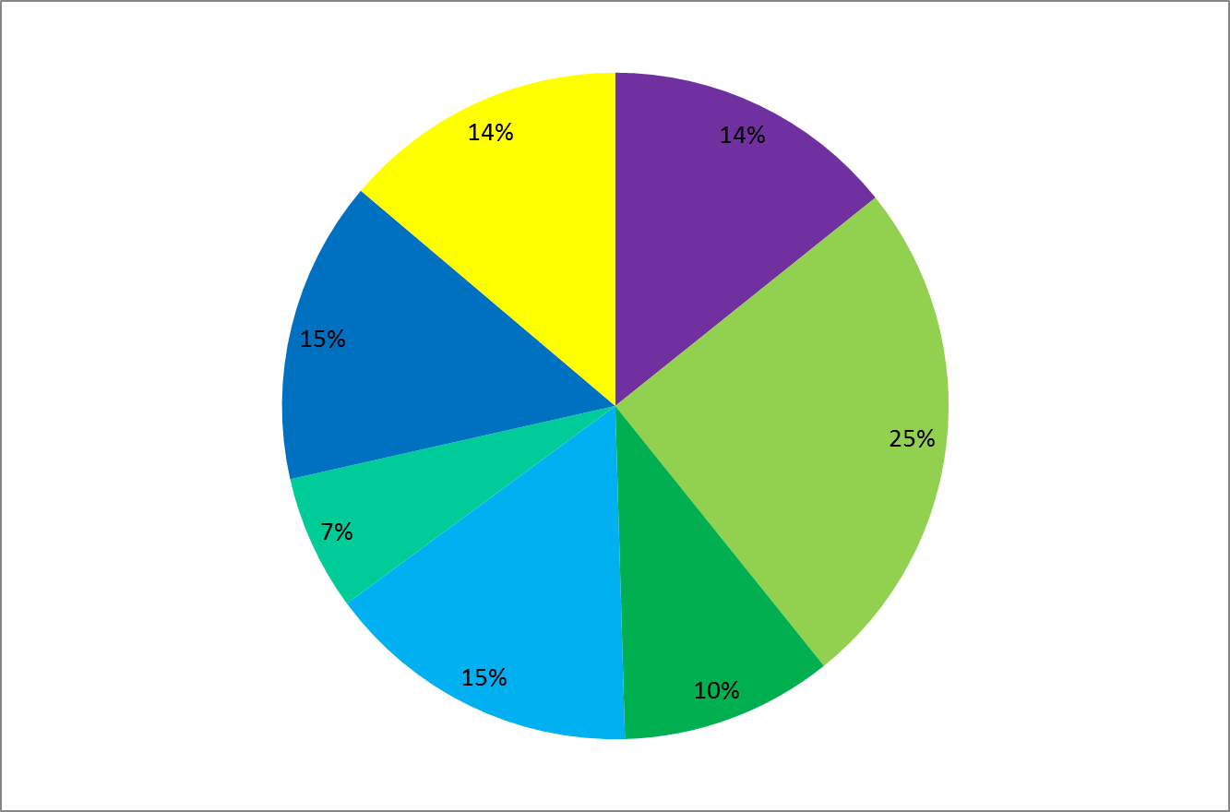

**Activity 2019/20**

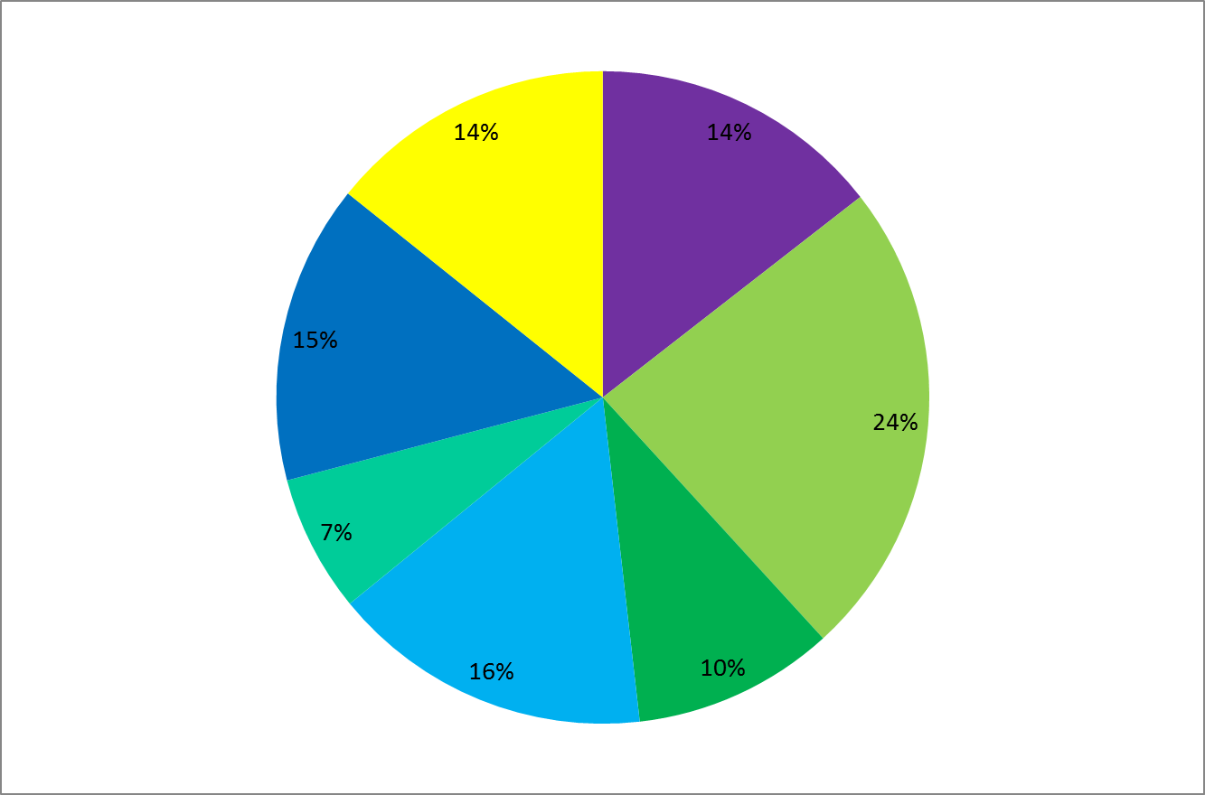

Data for 1st April 2019 to 31st March 2020

**Number of Inbound Referrals received (8827 Referrals) Number of Outbound Referrals made to Agencies (7667 Referrals)**



**Our Top 5 referring partners during 2019/20 have been as follows:**

Leicestershire Partnership Trust

General Practitioners

Adults & Communities

Self-Referrals

Lightbulb







The Warms Fund will be launching shortly allowing residents of Leicestershire to apply for fully-funded gas central heating*. To find out more visit Leicestershire.gov.uk/warm-homes-fund or call 0116 305 4286. Referrals can also be made via [First Contact Plus](http://www.firstcontactplus.org.uk/making-a-referral/)

*subject to eligibility criteria